**ICB CDR Generation Script Automation**

1. Install below mentioned python libraries

* Pandas
* Tkinter
* Subprocess
* Datetime

1. There are 1 main code and 4 sub-codes. Update location values in the sub-codes

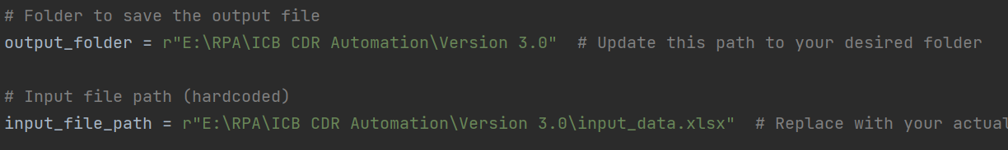

1. Keep all python files, input files and UNL file in the same directory.
2. Input TAPCODE, DATE & TIME in the sheet1 of excel. Other parameters will be automatically fetched from sheet2.

1. Run the main code and select the event for which CDR needs to be generated.

1. Output will be saved automatically in the respective event files.